**SAN JOSE STATE UNIVERSITY**

**dEPARTMENT OF ELECTRICAL ENGINEERING**

**SPRING 2016**

**EE283 - Broadband Communication Networking**

**Project on Implementation of VLANs using open vSwitch (OVS)**

**SUPERVISOR: Prof. NADER MIR**

**TEAM MEMBERS:**

**PALAK JOSHI – 010755199 (EE283-02)**

**INDUJA MARAMRAJ – 010756980 (EE283-01)**

**TABLE OF CONTENTS**

1. Objective ………………………………………………………………………...1
2. Abstract ………………………………………………………………………….1
3. Introduction ……………………………………………………………………...1
4. Procedure ………………………………………………………………………...2
5. Output …………………………………………………………………………....3
6. Conclusion ……………………………………………………………………......9
7. References………………………………………………………………………...9

**LIST OF FIGURES**

Fig. 1 Model of execution

Fig. 2 VM1 sending a ping request to VM2

Fig. 3 VM1 sending a ping request to VM3

Fig. 4 VM2 sending a ping request to VM1

Fig. 5 VM2 sending a ping request to VM3

Fig. 6 VM3 sending a ping request to VM1 and VM2

**OBJECTIVE**

The objectives of this project are:

to practice virtualization in networking

to implement VLANs within a virtualized network using an *Open vSwitch* (OVS)

**ABSTRACT**

This project aims at understanding how virtualization is done in networks by taking an illustration into consideration. Open vSwitch is used to implement Virtual LANs. A virtual switch is created where connection of multiple hosts is made possible. It is performed on an Ubuntu system.

**INTRODUCTION**

Virtualization:

Virtualization means to create a virtual version of a device such as server, storage device, network or operating system which enables the division of the framework into one or more execution environments. Even the partitioning of a hard drive is considered as virtualization. There are number of computational technologies that associated with virtualization nowadays such as storage virtualization, server virtualization, Operating-system level virtualization, Network virtualization and application virtualization. Virtualization is a combination of software and hardware engineering that creates Virtual Machines (VMs) - an abstraction of the computer hardware that allows a single machine to act as if it where many machines. The advantage of virtualization is the reduced cost of maintenance and reduced energy wastage. There are fewer physical servers therefore maintenance becomes much easier and cheaper too. As for energy conservation, it is fairly implicit. The amount of energy wasted is a function of the number of physical servers is clearly much lower in a virtualized environment.

VLAN:

A VLAN allows multiple computers and users to communicate in a simulated environment as if they exist in a single LAN and are sharing a single broadcast and multicast domain. VLAN removes latency in the network thus increasing the efficiency of the network.

The key benefits of implementing VLANs include:

* Additional security applied to network communication.
* Expansion and relocation of a network possible.
* Providing flexibility by enabling centralized configuration of the devices located in different geographical locations.
* Decreasing the latency and traffic load on the network and the network devices, offering increased efficiency.

Open vSwitch:

Open virtual switch (Open vSwitch) is a software implementation of a virtual multilayer network switch that allows one virtual machine to communicate with the other. A virtual switch not only forwards packet but also communicates directly on the network by inspecting packets before passing them on. Nowadays virtual switch is also incorporated in Software-defined Networking (SDN). It ties together all the VMs within a hypervisor on a server. It is the first entry point for all the VMs sending traffic to the network and is the ingress point into overlay networks running on top of physical networks in the data center. Using OVS for virtual networking is considered the core element of many data center SDN deployments and used in [network virtualization](https://www.sdxcentral.com/flow/network-virtualization/?utm_source=pink_ball&utm_medium=link&utm_campaign=links&utm_content=network-virtualization://).

**PROCEDURE**

The illustration that is implemented is

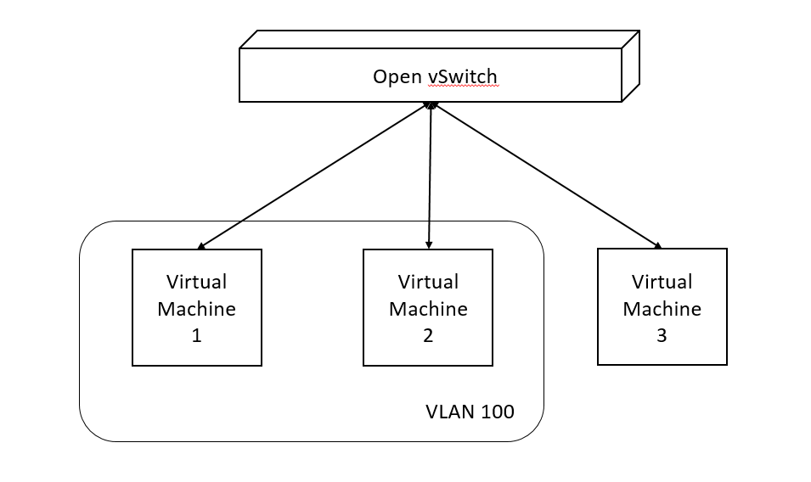

***Figure 1***

This model shown in ***Figure 1*** consists of three different virtual machines and a virtual bridge which would be the Open vSwitch. A VLAN is given an ID of 100. Two ports, Virtual Machine 1 and Virtual Machine 2 are assigned to the VLAN with the ID 100. Another VLAN is present which is a native VLAN and its VLAN ID would be 0. Virtual Machine 3 is assigned to the native VLAN.

The execution of the project is started by installing the required software. Ubuntu is first installed followed by Open vSwitch and then virtual box is downloaded later.

* Open vSwitch is then booted and configured.
* The kernel modules of Open vSwitch are installed.
* OVS data base is created.
* Open vSwitch is started and its operation is verified.
* Three Virtual Machines are set up.
* The VLANs are configured on the vSwitch.
* VM1 and VM2 are assigned a VLAN ID of 100 amd VM3 is assigned to the native VLAN.
* IP addresses are assigned to the three virtual machines.
* The VMs are pinged among each other to observe the output of the simulation.

**OUTPUT**

The output of the above procedure is explained in this part of the report. It contains of the simulation showing the VLANs, Virtual Machines and the communication in between them.

Three Virtual Machines, VM1, VM2 and VM3 are set up with the IP addresses 192.168.50.2, 192.168.50.3 and 192.168.50.4 respectively. VM1 and VM2 have a VLAN ID of 100 and VM3 has a VLAN ID of 0.

**VM1**

In ***Figure 2*** we observe that VM1 is sending a ping request to VM2 with IP address 192.168.50.3 and the request returns successfully. It means that VM2 is reachable through VM1. This is possible because VM1 and VM2 have the same VLAN IDs.

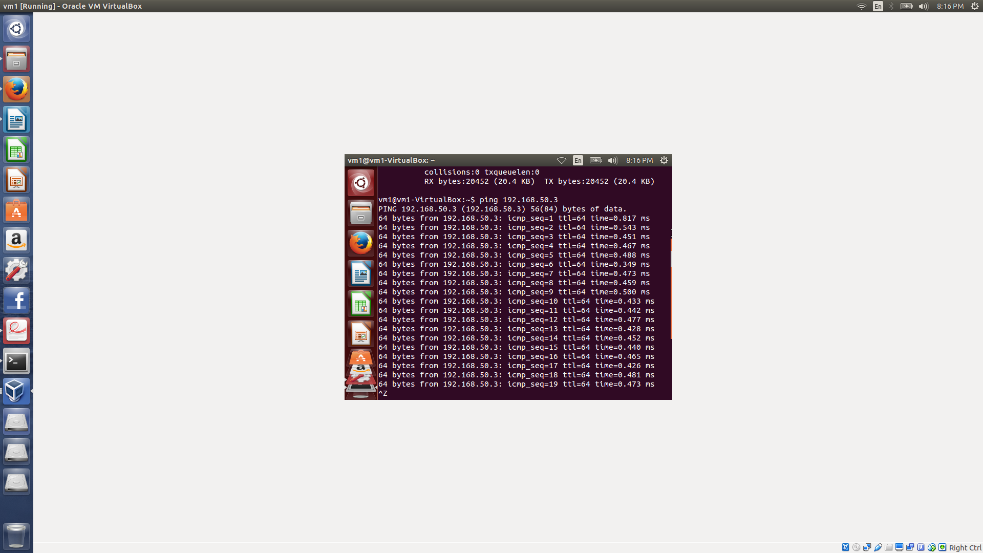

***Figure 2***

In ***Figure 3*** we observer that VM1 is sending a ping request to VM3 with the IP address 192.168.50.4 but the request does not return successfully. This means that VM3 is unreachable through VM1. It is because VM1 and VM3 do not have the same VLAN IDs.

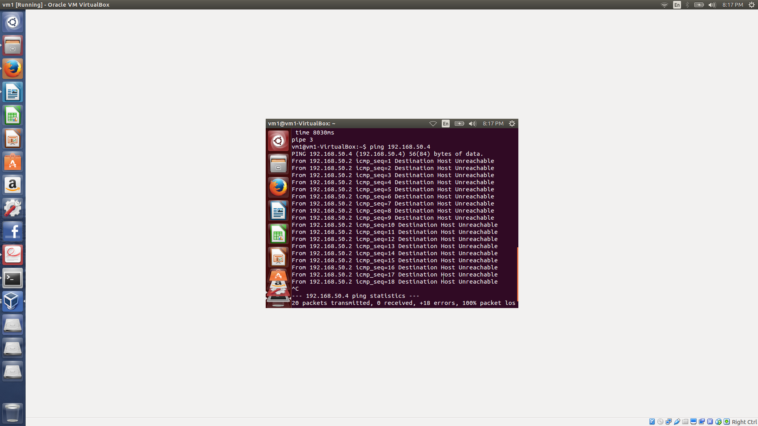

***Figure 3***

**VM2**

In ***Figure 4*** we observe that VM2 is sending a ping request to VM1 with the IP address 192.168.50.2 and the request returns successfully. It means that VM1 is reachable through VM2. This is because VM1 and VM2 have the same VLAN ID.

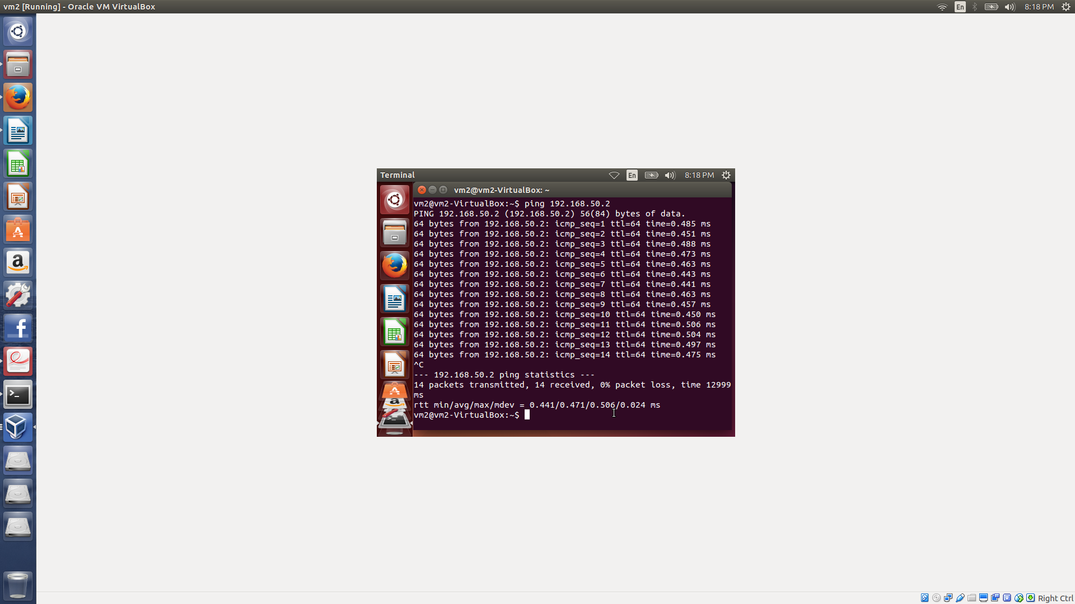

***Figure 4***

In ***Figure 5*** we observe that VM2 is sending a ping request to VM3 with the IP address 192.168.50.4 but the request does not return successfully. This means that VM3 is unreachable through VM2. It is because VM2 and VM3 do not have the same VLAN IDs.

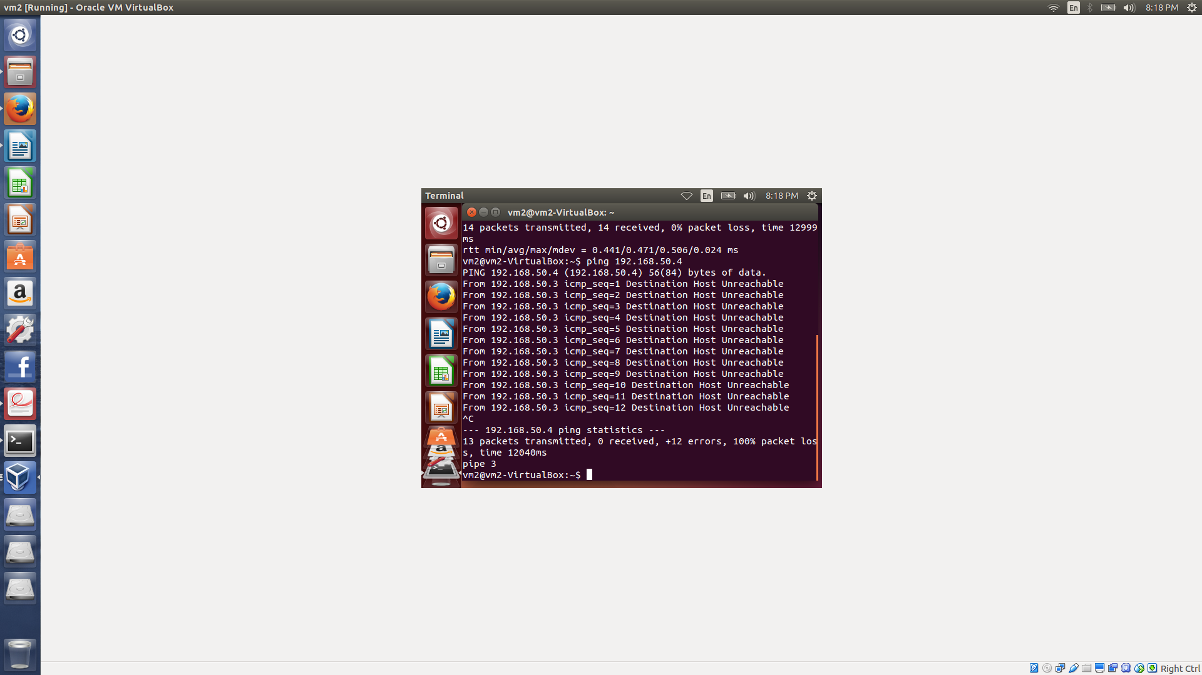

***Figure 5***

**VM3**

In ***Figure 6*** we can observe that when VM3 is trying to send a ping request to VM1 with the IP address 192.168.50.2 or VM2 with the IP address 192.168.50.3, the request does not return successfully. It means that VM1 and VM2 are unreachable through VM3. This is because VM3 does not have the same VLAN ID as VM1 or VM2.

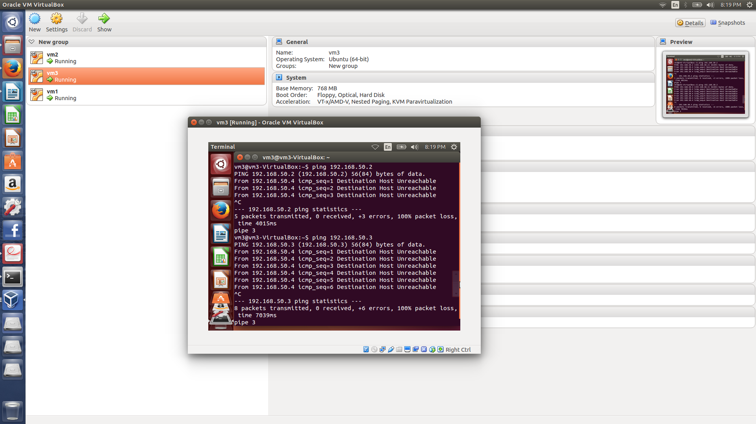

***Figure 6***

**CONCLUSION**

In the project the concept of virtualization, vSwitch and the simulation of virtual computer network using the Open vSwitch were studied. A detail analysis was done during the configuration of VLANs to understand the uses of VLANs, and the simulation of the Virtual Machines.

**REFERENCES**

[www.wikipedia.org](http://www.wikipedia.org)